**Portfolio Project**

*System Selection*

I was having trouble selecting a topic to work on during the time of this course. Therefore, I chose from the provided list of ideas. The Design and Implementation of a Project Management API using Python and Blockchain Technology seemed to pop out at me. I am not sure if we will be implementing the project or just focusing on the development process of the project but I would always love to learn more about blockchain. However, I would still enjoy setting up the development process for such a project. I would like to start setting up a Kanban board for this project. Kanban boards might be the most useful part of the development process for me.

*Engagement Level Diagram*

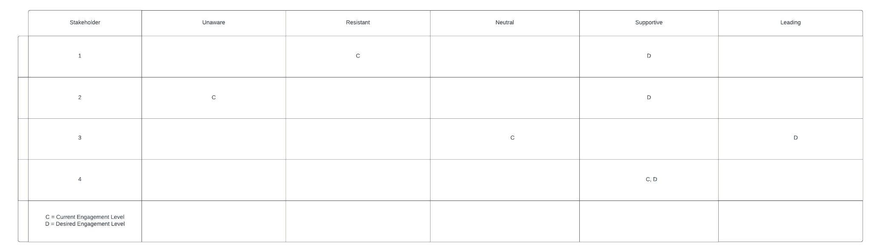

Stakeholder 1 is currently resistant to the project but we want them to be supportive. They are being resistant due to potential unknown costs with the blockchain project. Neutral could be better but we really need to get all stakeholders onboard with our blockchain project. Perhaps they have been misinformed and we can talk over the details again, in order to try and move stakeholder 1 from resistant to supportive.

Stakeholder 2 is currently unaware of the new blockchain project. Therefore, we need to inform the stakeholder of the new project and explain the details. Explaining the detail and how it will help the company ought to make stakeholder 2 move from the unaware status to the desired supportive status. Unless the stakeholder is out of the office we need to contact them immediately and inform them of the new blockchain project.

Stakeholder 3 is currently neutral towards the project but we are hoping to put the stakeholder into the leading status. This stakeholder has a lot of experience and connections in the blockchain world and would be highly beneficial to the project. We need to go over any misinformation the stakeholder may have heard. Even though the stakeholder is not negative towards the project, their background would make it highly positive if they were in the leading status.

Stakeholder 4 is currently supportive and is desired to be supportive. This is the goal of where stakeholders should be. The current and the desired engagement levels always strive to be in the same status. Not much is needed to be done with this stakeholder. We simply need to make sure they remain at their current engagement level.

*The Project Plan*

The work breakdown structure for my blockchain will be completed by the end of this course. Therefore, I broke up the sprints into the number of remaining weeks left in this course. Week long sprints ought to be manageable, given the scope of this project. The first sprint will consist of any additional research needed along with prototyping with the concepts and packages. The following sprints will consist of completing fully functional versions of this blockchain project.

To stay on track during the sprints we will be using a kanban board. The kanban board will contain tasks specific to each sprint. The tasks per sprint will be determined by assigning a cost value to each task. The total cost of the project will be split up evenly into each sprint. Furthermore, each task will also have an acceptance criteria determined by a given user story. For example, the user should be able to click a button and then display whether or not a given blockchain’s hash value is valid.

User stories may be the driving factor for creating individual tasks. However, requirements for the tasks will need to be figured out before we begin. The requirements are relatively simple but can be detrimental if they are missing. We will need Python 3, pip, python’s pybitcoin package, as well as any and all of the dependencies. The requirements may change over time. Therefore, the requirements will be placed in our requirements.txt file. This file will help keep all the potential developer’s environments on the same page.

In summary, the scope of this project is roughly four weeks long and will contain four sprints. The tasks will be broken down and placed on a kanban board. The kanban board will keep everything on track as well as improving transparency among the team. The user stories will determine the acceptance criteria. By the end of the four weeks a user should be able to easily interact with the completed project.

*The Project Design and Outline*

***Quick Overview:***

* Research python API development
* Research python blockchain development
* Build simple blockchain program
* Build simple API program
* Combine simple projects into a minimum viable product
* Unit testing with pytest
* Expand and deploy project

***Budget:***

The budget must cover the cost for development, time spent, and server space for deployment. The budget will come from the investors.

***Resources:***

Resources required include server space for deployment and computers for development. The development team will determine the required amount of server space needed as well as the computers needed for development.

***Stakeholder analysis:***

Stakeholders include business partners, investors, employees, potential customers looking for a project management API. The business partners and employees will have a high amount of influence. The investors will have some influence and interest. Therefore, we will keep them informed and they will be monitoring the project. Potential customers will not have much influence but will have a higher amount of interest and we should keep them informed.

***Rough outline:***

The beginning stage of the project will be spent researching the required technologies. The technologies include creating blockchain with python, API development, and project management tools. Once research is done, prototyping blockchain and an API will take place. The prototypes will help with understanding the technology before expanding the project to a minimum viable project. To keep the project on track we will use unit tests with python’s pytest package. Pytest will also help with the maintenance portion of the project. In order to finish by the end of this class, this project will be completed in about 3-4 sprints.

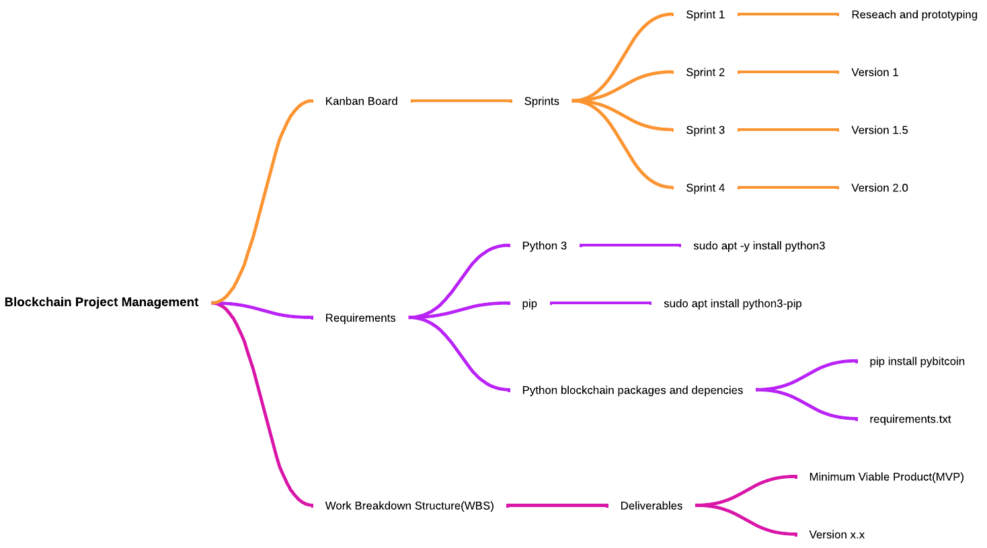

*Design Methodology*

The beginning phases for the design methodology includes planning and research. Planning will include processes such as developing a gantt chart, stakeholder analysis, project scope, etc. Once the planning is done, we can move onto the research portion. For our particular project, research will primarily focus on developing APIs and blockchain with the python programming language. Research on APIs and blockchain will lead to developing small prototypes of each concept.

The small prototypes will help make sure the concepts are understood and can be implemented. While developing, even just the prototypes, we need to put unit testing in place. Unit testing will be done with python’s pytest package. Ensuring the project passes unit tests early on will make sure the project doesn't get out of control and create scope creep. Successful prototyping should lead to the creation of a minimum viable product(MVP).

The MVP is when we will really be able to see how the project is turning into an actually functional project. However, an MVP still needs further development and debugging before it makes it to deployment. Unit testing will continue to help with the further development and debugging processes until the project is considered deployment worthy.

Once the project is processed into a deployment worthy version we can deploy it and start focusing on maintenance. The maintenance process will include updating any out of date packages, squashing bugs that come up, and ensuring the server is hosting the project correctly and efficiently. Additionally maintenance will cover any other issues that come up with the deployed project. At this point we can also start expanding the project into another version, to be deployed as an update in the future.

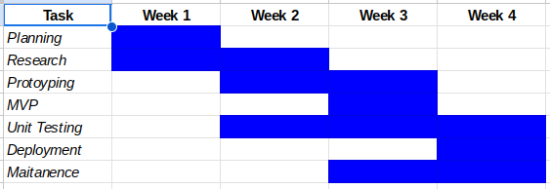

Gantt Chart

*The Risk Matrix*

Since our blockchain project is still in its infancy there are some risks that could derail the system. Some of the potential risks include a halt on funding, gold plating, server malfunction, cyber attacks, and coworker issues at the workplace. In order to measure each potential risk, each risk has been placed into a risk matrix. The risk matrix allows them to be measured and sorted. Thus exposing the deadliest risk, the risk with minimal concern, and all the other risks in between.

According to our risk matrix the deadliest risk is gold plating. Gold plating is the deadliest risk because the project has already experienced it and has fallen a bit behind because of it. Therefore, going forward we need to be extremely cognisant of gold plating, in order to prevent any further delays. Even though gold plating is our primary risk there are still other risks that could bring a halt to our blockchain project.

One of our other main threats is a cyber security attack. Cyber security attacks can happen to any software platform and thus should be taken seriously. Therefore the developers need to make sure the platform is as secure as possible before the first deployment. Additionally, defense against a cyber security threat will be a primary part of maintaining the deployed version. Unfortunately, gold plating and cyber security threats are not the only risks associated with the project.

Other potential risks include halt on funding, server malfunction, and coworker issues in the workplace. According to the risk matrix, these risks rank lower than the previously stated two risks, however, they still need to be taken into consideration. Investors could stop funding the project, the servers could quit working, and/or there could be internal issues between co-workers. All of which would bring delays or completely derail the project.

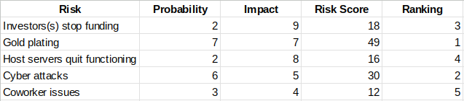

Risk Matrix